

**Lab: Wireshark ACME Corporate Breach**

**Purpose**

In this lab, we are going to demonstrate how **Wireshark** can be used to conduct effective forensic investigation in case of data breach in a realistic corporate network.

**Pre-Requisite**

Before you can start the lab, you need to run the lab script which will setup everything. Open the **Labs** folder on Desktop then right-click and “Open Terminal Here”. Or open a terminal and cd to Desktop/Labs folder, then issue the command: sudo ./main_script.sh

Select **Wireshark ACME Corporate Breach Lab** option from the lab menu.

# Scenario

ACME Corp’s security team has been alerted to suspicious activity on their internal network. An alert flagged potential unauthorized access to sensitive data. Your task is to analyse the captured network traffic and reconstruct the sequence of events, especially how the attack happened.

A **pcapng network capture** (acme-corporate-forensics.pcapng) from the company’s monitoring system has been handed over to you to conduct forensic investigation. Please open the

file /home/kali/Desktop/Labs/wireshark-acme-corporate/acme-corporateforensics.pcapng in Wireshark.

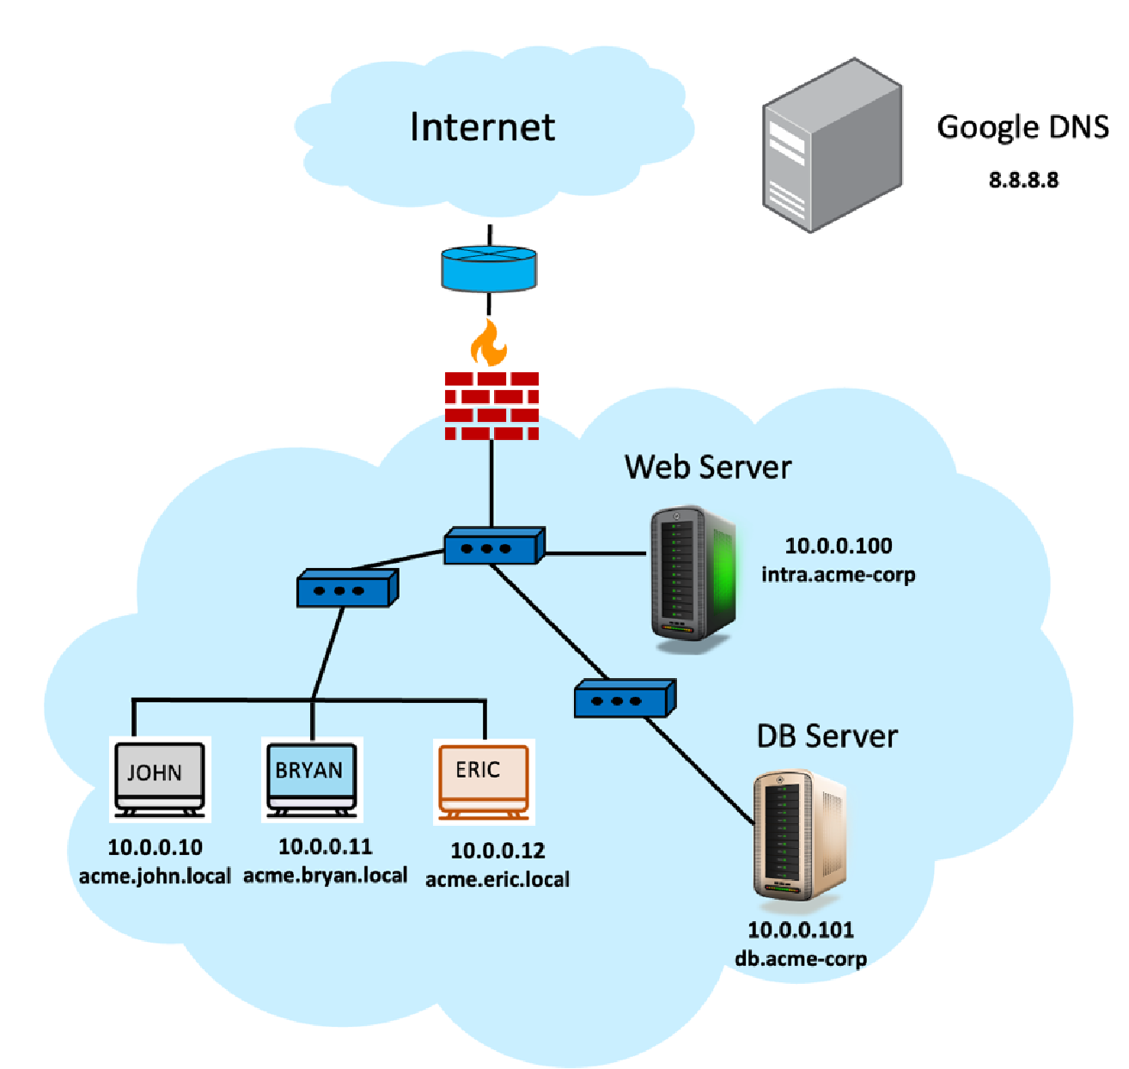



|  |  |  |
| --- | --- | --- |
| Device / Role | Hostname | IP Address |
| John’s workstation | john.acme.local | 10.0.0.10 |
| Bryan’s workstation | bryan.acme.local | 10.0.0.11 |
| Eric’s workstation | eric.acme.local | 10.0.0.12 |
| Web Server | intra.acme-corp | 10.0.0.100 |
| Database Server | db.acme-corp | 10.0.0.101 |
| Mail Server | mail.acme-corp | 10.0.0.102 |
| DNS Server | Google DNS | 8.8.8.8 |

By the end of this lab, you should be able to:

* Detect and interpret attack vectors
* Analyze DNS queries and HTTP payloads to identify malware activity.
* Trace unauthorized queries to internal servers (e.g., web or database servers).
* Detect and prove data exfiltration.
* Use Wireshark’s **display filters** and **TCP stream reconstruction**

# Investigation Tasks & Questions

**Part 1: Baseline Traffic Familiarization**

• Identify any email traffic sent internally — who sent it and what was the content?

Answer: I sent it unofficially to someone, as mentioned in the screenshot below, and his IP Address is **198.51.100.5.** Content is below the screenshot

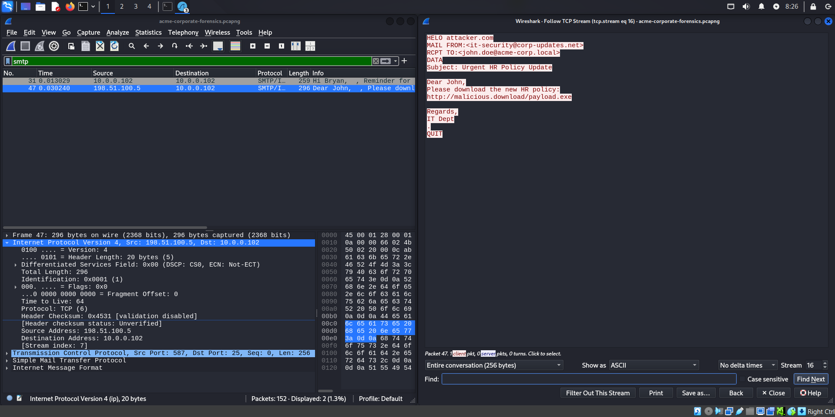

## Part 2: Attack Detection

* What attack vector was used? remote code execution, brute-force login, or phishing?
* Yes, it is a phishing email.
* Which employee was the target (give the IP address of his station)?
* Target IP is 10.0.0.10, and the attacker mentioned JOHN in the mail recipient’s main section.
* (Hint: focus on the usual suspects HTTP, DNS, SMTP traffic).

## Part 3: Malware Execution & Communication

* How did the malware installation take place exactly, what was the source of the malware?
* Yes, he clicks on that, click includes the malicious mail

* What was the name of the malware process?   
  payload.exe

## Part 4: Internal Database Reconnaissance

* Which internal servers or services did the malware try to access?

He has access to the database server, so I can find the port 3306, so it's normally defined for SQL database servers

* What data was retrieved by the malware running on the compromised system?   
  He gets the employee's username and passwords, the employee's salary, emails and contact numbers

## Part 5: Data Exfiltration

* Identify the session where the stolen data is exfiltrated to an external IP.

Admin passwords username phone number and etc

* Is it the same remote IP/host as the one that was involved in malware installation?

No different IP, and it is 203.0.133.77

* Capture a screenshot of the exfiltrated credentials or salary data

**(Solution in next lecture)**